**Project Initialization and Planning Phase**

| Date | 9 December 2024 |
| --- | --- |
| Team ID | 739876 |
| Project Name | Alzheimer Disease Prediction |
| Maximum Marks | 3 Marks |

**Define Problem Statements (Customer Problem Statement Template):**

Many individuals and their families face significant uncertainty and distress when dealing with the possibility of Alzheimer’s disease. They struggle with delayed diagnosis due to invasive tests, and expensive diagnostic tools that are often inaccessible or unaffordable. This delay prevents timely intervention, limiting the ability to slow disease progression or make informed care decisions. Patients and caregivers desire a solution that provides an early, accurate prediction. They want an affordable, easy-to-use, and reliable tool that empowers them to take control of their health, plan for the future, and access treatments or support at the right time. This understanding highlights the emotional, financial, and logistical challenges customers face, helping us design solutions that meet their needs and improve their experience.

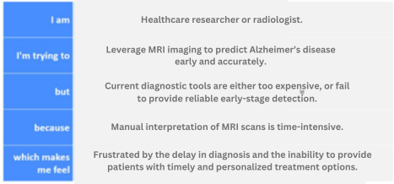

**Example:**

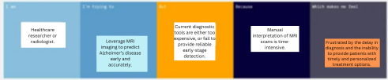

|  |  |  |  |  |  |
| --- | --- | --- | --- | --- | --- |
| **Problem**  **Statement (PS)** | **I am**  **(Customer)** | **I’m trying to** | **But** | **Because** | **Which makes me feel** |
| PS-1 | Healthcare researcher or radiologist. | Leverage MRI imaging to predict Alzheimer’s disease early and accurately. | Current diagnostic tools are either too expensive, or fail to provide reliable early-stage detection. | Manual interpretation of MRI scans is time-intensive. | Frustrated by the delay in diagnosis and the inability to provide patients with timely and personalized treatment options. |